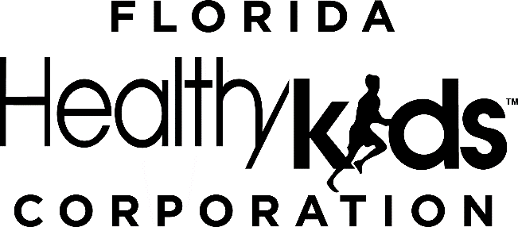

Request for Proposal 2023-300-02
for
Medical Loss Ratio Audit Services
ADDENDUM 1
June 23, 2023

- Overview of Addendum 1
The Florida Healthy Kids Corporation (FHKC) is amending Request for Proposal 2023-300-02 (“RFP”) to answer questions from potential respondents.
- Addendum 1
Addendum 1 (“Addendum”) to the RFP is as follows:

FHKC’s answers to Respondents’ questions are as follows:
# | Document Reference | Document Page # | Question | Answer
1 | RFP, Section 1. C | 5 | Has an MLR audit been performed in the past? If so, can you tell us who performed it in the past? | No, an MLR audit has not been performed in the past.
2 | Attachment 1. Section 3 | 13 | Can you provide the testing period of service for year one and year two? (Calendar year or a fiscal year) | Calendar year
3 | RFP, Section 2. A. 1 | 8 | “Vendor will audit the MLR reports for FHKC’s three health plan MCOs…” Can you provide a copy of the MLR reports from each of the three health plan MCOs for the fiscal year ended June 30, 2022? | No. The health plan MCOs’ contracts run on the calendar year, not the fiscal year. The awardee will be provided with all applicable MLR reports.
4 | RFP, Section 8. Attachment 2. Section VI | 33 | “Respondent is audited and/or certified by recognized security standards…” We outsource our entire IT environment and management to a third party. The third party is audited and has a SOC 2, and we can get a letter from the auditor stating that it has performed a SOC 2. However, they require NDAs to see these SOC 2 reports. Is the letter sufficient for this response, or are you willing to sign an NDA to view the SOC 2? | FHKC is willing to sign an NDA. Respondent may submit a draft NDA with the proposal. FHKC may need to make edits to the NDA based on federal and state requirements. Once Respondent and FHKC agree upon an NDA and the NDA has been executed, Respondent shall submit the required report within one business day of receipt of the executed NDA.
5 | RFP, Tab B Minimum Qualifications | 21-22 | Is the expectation that final report by signed by CPA firm registered in state of Florida? | No, the CPA firm is not required to be registered in the state of Florida.
6 | RFP, Tab E Letter of Agreement | 25 | If we have no exceptions/requests for change to the Draft Contract, please confirm that we should not provide a Letter of Agreement? | The Letter of Agreement is optional.
7 | RFP, Tab D Technical Response | 24-25 | Can the Corporation clarify whether we are to report separate medical loss rations for each health plan AND each region the health plans participate in, or does the Corporation expect a combined medical loss ratio for each health plan encompassing all regions for the CHIP and full-pay enrollees? | FHKC expects a single MLR for each health plan for each contract year audited.
8 | RFP, Tab C. 3 Financial Solvency | 23 | As a CPA firm we do not have audited financial statements, would you accept unaudited statements certified by our firm? If not, do you consider Dun and Bradstreet ratings to be a “credit rating agency designated as a nationally recognized statistical rating organization by the Securities and Exchange Commission?” | Yes, we will accept unaudited statements certified by the firm.
9 | RFP, Section 5 Cost Proposal | 26 | Does the Corporation have an anticipated annual budget for the medical loss ratio audits? | Yes.

To the extent this Addendum conflicts with any previous written or oral ITN specifications, instructions, or information provided by FHKC, this Addendum shall control.

Remainder of this page intentionally left blank

Any party that has standing to challenge an FHKC Intended Decision must file a written notice of intent to protest, formal written protest, and any required bond or other security as set forth in Appendix C of the Invitation to Negotiate. Failure to timely file a notice of intent to protest, formal written protest, or any required bond or other security shall constitute a waiver of proceedings.

Remainder of this page intentionally left blank

